

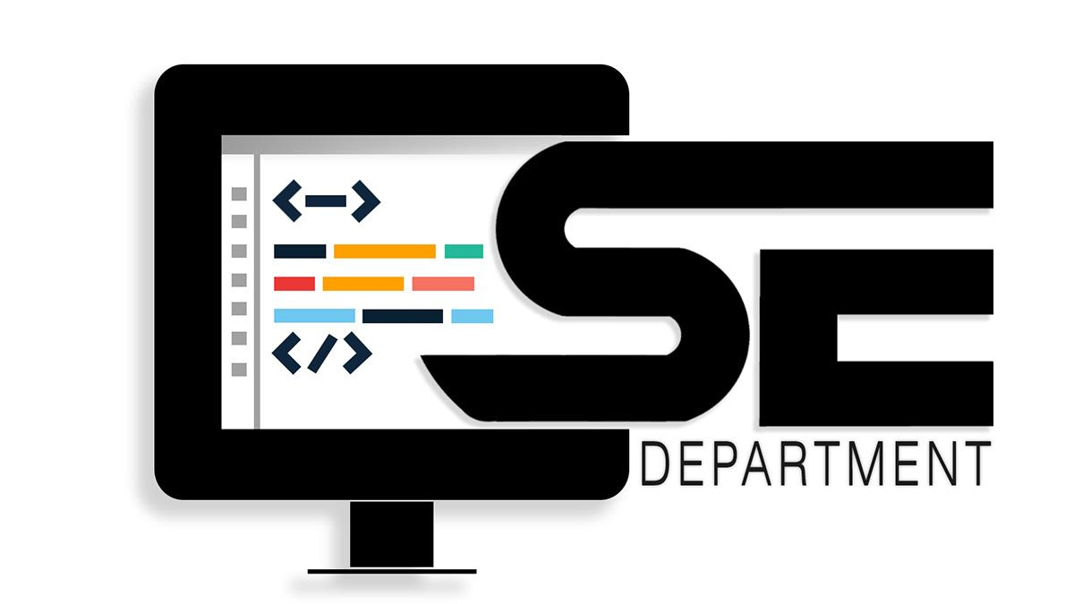

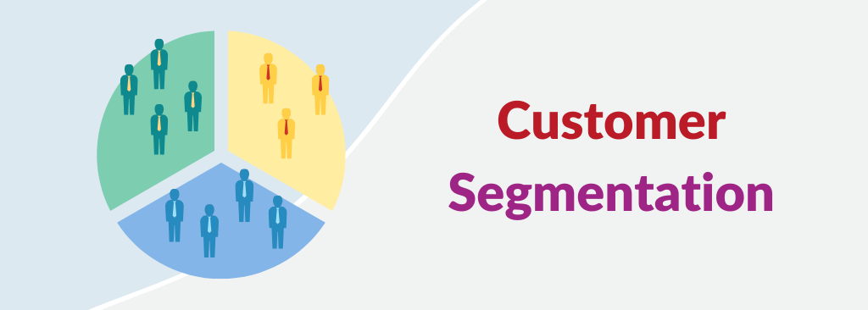

**APPLIED DATASCIENCE PHASE 4**

**TEAM MEMBERS:**

1. **U. SWATHI**
2. **A.VIDHYA**
3. **U.SNEHA SRI**
4. **K.PAVITHRA**

**FEATURE ENGINEERING:**

Feature engineering is a crucial step in customer segmentation. It involves selecting, transforming, or creating relevant features from your data to improve the quality of your customer segments. Effective feature engineering can lead to more meaningful and actionable segments. Here are some techniques and considerations for feature engineering in customer segmentation:

1. **Feature Selection:**
   * Start by selecting the most relevant features for your segmentation task. Features that are not informative or redundant can add noise to the clustering process. Use domain knowledge and statistical methods to identify the most important variables.
2. **Scaling and Standardization:**
   * Ensure that the numerical features are on a similar scale to prevent features with larger magnitudes from dominating the clustering. Common methods for scaling include Min-Max scaling (scaling to a specific range) and standardization (scaling to have mean 0 and standard deviation 1).
3. **Handling Categorical Variables:**
   * If your dataset includes categorical variables (e.g., customer segments, product categories), you'll need to encode them numerically. Common techniques include one-hot encoding, label encoding, or binary encoding.
4. **Handling Missing Values:**
   * Deal with missing data appropriately. You can either impute missing values with appropriate statistics (mean, median, mode) or use advanced imputation techniques such as K-nearest neighbors (K-NN) imputation.
5. **Creating Derived Features:**
   * Sometimes, creating new features can enhance the clustering process. These features might capture more information than the original features. For example:
     + Create aggregated features like total purchase amount, average order value, or frequency of interactions.
     + Calculate ratios or percentages, such as the proportion of purchases from different product categories.
     + Time-related features, like recency or the frequency of visits or purchases.
6. **Dimensionality Reduction:**
   * In cases of high-dimensional data, consider using dimensionality reduction techniques to reduce the number of features while retaining most of the information. Principal Component Analysis (PCA) or t-Distributed Stochastic Neighbor embedding (t-SNE) are common choices.
7. **Engineering for Specific Insights:**
   * Sometimes, specific features might be engineered to capture domain-specific insights. For example:
     + Customer lifetime value (CLV) can be used as a feature to identify high-value customers.
     + Customer behavior patterns, such as morning shoppers, night shoppers, or weekend shoppers.
     + Customer engagement scores based on website clicks, email interactions, or app usage.
8. **Creating Customer Similarity Metrics:**
   * In some cases, you might engineer features that measure the similarity between customers, which can be used in clustering. For example, cosine similarity, Euclidean distance, or correlation coefficients between customer profiles.
9. **Data Transformation:**
   * Transforming your data through mathematical operations can also lead to more informative features. Logarithmic transformations or other mathematical operations can help normalize the distribution of certain features.
10. **Regular Feature Updates:**
    * Remember that customer behavior and preferences can change over time. It's essential to update and refresh your features as new data becomes available.
11. **Iterative Approach:**
    * Feature engineering is often an iterative process. You may need to try different features, assess their impact on segmentation, and refine them based on the results.

The effectiveness of feature engineering in customer segmentation depends on your understanding of the business problem, your domain knowledge, and the quality of the data you're working with. Continuously monitoring and refining your feature engineering process is crucial to achieving meaningful and actionable customer segments.

**APPLYING CLUSTERING ALGORITHMS:**

Applying clustering algorithms in customer segmentation is a critical step in the process of identifying and grouping customers with similar characteristics. Clustering algorithms help automate the segmentation process and uncover hidden patterns within your customer data. Here are some key clustering algorithms commonly used in customer segmentation:

1. **K-Means Clustering:**
   * K-Means is one of the most widely used clustering algorithms. It partitions your customers into K clusters, where K is a predefined number. Each customer is assigned to the nearest cluster center based on a distance metric (usually Euclidean distance). It's important to choose an appropriate value of K, which can often be determined using techniques like the elbow method or silhouette score.
2. **Hierarchical Clustering:**
   * Hierarchical clustering builds a tree-like structure (dendrogram) of clusters. You can cut the dendrogram at different levels to obtain different numbers of clusters. Agglomerative clustering starts with individual customers as clusters and progressively merges them, while divisive clustering begins with all customers in one cluster and divides them iteratively.
3. **DBSCAN (Density-Based Spatial Clustering of Applications with Noise):**
   * DBSCAN identifies clusters based on the density of data points. It doesn't require specifying the number of clusters in advance. DBSCAN can uncover clusters of arbitrary shapes and is robust to noise. It distinguishes between core points, border points, and noise points.
4. **Agglomerative Clustering:**
   * Agglomerative clustering is a hierarchical method that starts with each data point as a single cluster and merges clusters iteratively based on a distance metric. It is flexible and can produce a hierarchy of clusters.
5. **Gaussian Mixture Models (GMM):**
   * GMM is a probabilistic clustering method that models the data as a mixture of Gaussian distributions. It can discover clusters of varying shapes and sizes and assign probabilities of membership to each data point for each cluster.
6. **Self-Organizing Maps (SOM):**
   * SOM is a neural network-based clustering method that maps high-dimensional data to a lower-dimensional grid. It captures the topological relationships between data points and is useful for visualizing clusters on a 2D grid.
7. **Mean-Shift Clustering:**
   * Mean-shift is a density-based clustering algorithm that identifies clusters by finding local maxima in the data density. It doesn't require specifying the number of clusters and is effective in cases with irregularly shaped clusters.
8. **Fuzzy Clustering (Fuzzy C-Means):**
   * Fuzzy clustering allows data points to belong to multiple clusters with varying degrees of membership. This is useful when customers may exhibit mixed or uncertain behaviors.

**VISUALIZATION:**

Visualization plays a crucial role in customer segmentation, as it helps you understand the structure of your customer segments and communicate your findings effectively. Here is some common visualization techniques used in customer segmentation:

1**. Scatter plots**:

Scatter plots are a simple yet effective way to visualize customer segments in two-dimensional space. Each data point represents a customer, and their position on the plot is determined by two selected features. Different clusters can be visualized using different colors or markers.

2**. Heat maps**:

Heat maps can help you visualize the relationships between customer segments and multiple features simultaneously. The color intensity in the headman represents the magnitude of a particular metric, such as customer spending, across different segments.

3. **Dendrogram Plots**: Dendrogram plots are often used in hierarchical clustering. They display the hierarchical structure of clusters by showing the merging and splitting of clusters as you move from the leaves (individual data points) to the root (the entire dataset).

4**. Principal Component Analysis (PCA) Plots**:

PCA can reduce the dimensionality of your data while preserving most of the variance. You can use PCA to create 2D or 3D plots that visualize customer segments and the most significant dimensions (principal components) of your data.

5. **t-Distributed Stochastic Neighbor embedding (t-SNE):**

t-SNE is a dimensionality reduction technique that is particularly useful for visualizing high-dimensional data. It helps reveal the structure of clusters in a lower-dimensional space.

6**. Box Plots**:

Box plots can show the distribution of a specific feature within each customer segment, making it easy to compare the distributions and identify differences between segments.

7. **Parallel Coordinate Plots**:

Parallel coordinate plots are useful for visualizing high-dimensional data. Each axis represents a feature, and lines connecting data points reveal patterns in the data. You can use color-coding to indicate different segments.

8**. Cluster Profiles**:

Create visual profiles of each cluster by plotting the mean or median values of features for each segment. This helps in understanding the characteristics that define each segment.

9**. Chord Diagrams**:

Chord diagrams can be used to visualize relationships between segments. They can show how customers in one segment interact with or transition to another segment.

10**. 3D Plots**:

If you have a three-dimensional dataset, you can create 3D scatter plots or surface plots to visualize customer segments.

11**. Sankey Diagrams**:

Sankey diagrams can show the flow of customers from one segment to another over time. This is particularly useful in understanding customer transitions and churn.

12**. Geospatial Visualizations**:

If location data is a part of your customer dataset, you can create geographical maps to visualize the geographic distribution of customer segments.

13. **Interactive Dashboards**:

Tools like Tableau, Power BI, or Plotly can help you create interactive dashboards that allow users to explore and analyze customer segments in real time.

**INTERPRETATION:**

Interpretation in customer segmentation involves making sense of the results and drawing meaningful insights from the generated customer segments. Effective interpretation is essential for understanding the characteristics and behaviors of different customer groups and for making data-driven decisions. Here are key steps and considerations for interpreting customer segmentation results:

1. **Cluster Profiles:**

Examine the characteristics of each customer segment by analyzing the mean or median values of features within each cluster. This helps you understand what defines each segment. For example, you may find that one segment consists of high-value, frequent shoppers, while another consists of infrequent, low-value customers.

1. **Feature Importance:**

Determine which features or attributes contribute the most to the differentiation between segments. Techniques like feature importance scores or principal component analysis (PCA) can help identify the most influential factors in the segmentation.

1. **Segment Descriptions:**

Give each segment a meaningful and descriptive name or label. This makes it easier to refer to the segments and convey their characteristics to others within your organization.

1. **Customer Personas:**

Create customer personas for each segment, including a description of their demographics, behaviors, preferences, and pain points. Personas help humanize the segments and make it easier to empathize with and understand the customers within each group.

1. **Visualization:**

Use various visualization techniques (scatter plots, heat maps, box plots, etc.) to visually explore the differences and relationships between segments. Visualizations can help you see patterns and trends that might not be immediately apparent from the data alone.

1. **Silhouette Score:**

If you have used the silhouette score for cluster evaluation, pay attention to it. A higher silhouette score indicates that data points within a cluster are closer to each other than to those in other clusters, indicating good separation.

1. **Comparisons:**

Compare the segments against each other and against the general customer population. This allows you to determine which segments are overrepresented or underrepresented in your customer base and identify unique characteristics.

1. **Customer Journey Mapping:**

Create customer journey maps for each segment to understand how customers in that group interact with your products or services over time. This helps tailor marketing and customer engagement strategies.

1. **Hypothesis Testing:**

Formulate hypotheses about each segment's preferences and behaviors and then use A/B testing or other experimentation methods to validate these hypotheses. This can help ensure that the insights derived from segmentation are actionable and effective in practice.

1. **Feedback Loops:**

Continuously monitor and collect feedback from customers in each segment. This allows you to refine and adapt your segmentation strategy as customer behavior and preferences change.

1. **Alignment with Business Goals:**

Ensure that the interpretation of customer segments aligns with your business goals. Are you using these segments to increase sales, improve customer retention, enhance personalization, or achieve some other objective?

1. **Cross-Functional Collaboration:**

Involve stakeholders from different departments (marketing, sales, and product development) in the interpretation process. Their insights and expertise can provide a more comprehensive understanding of the segments and guide strategies for each group.

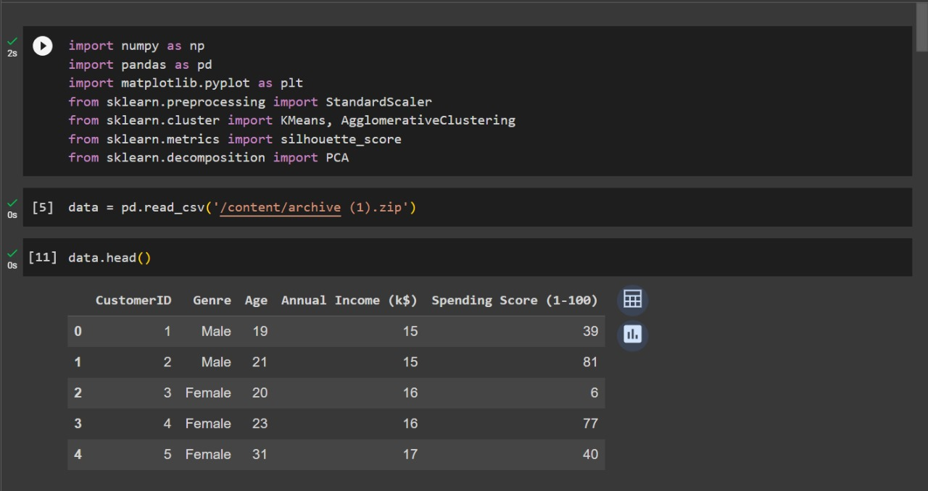

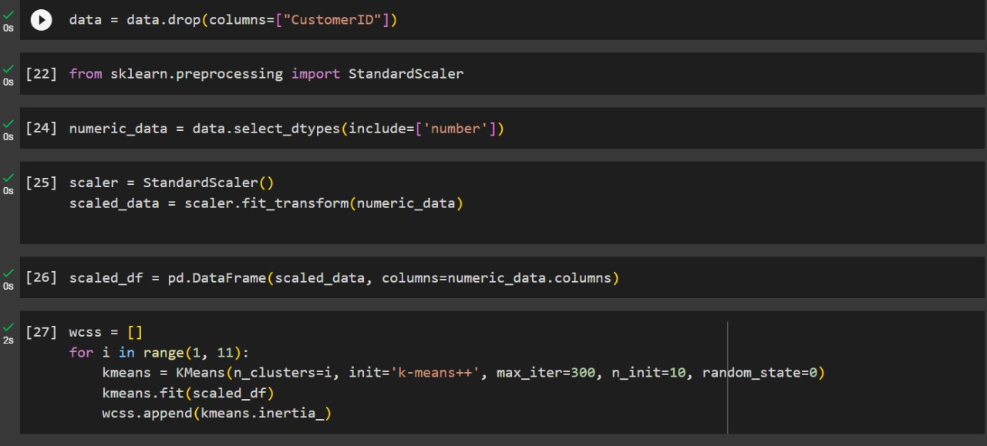

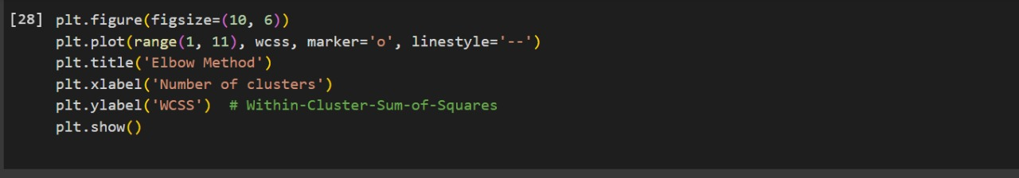

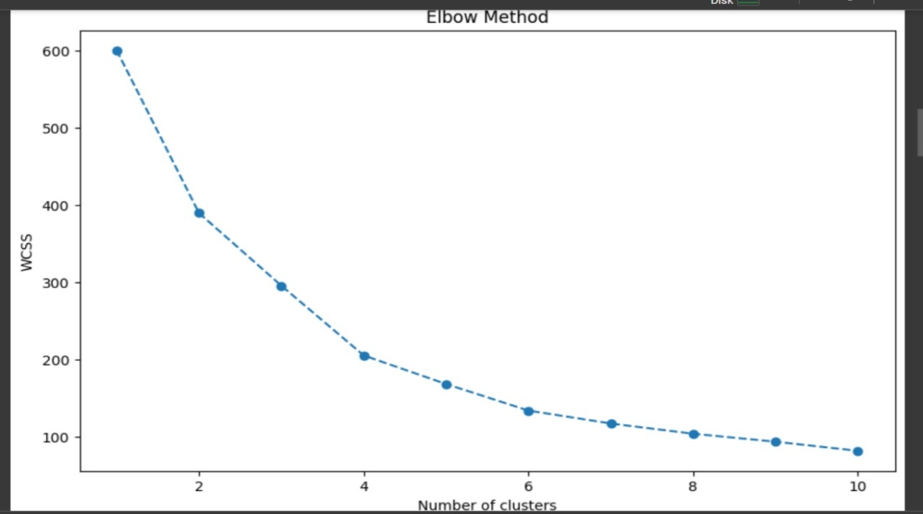

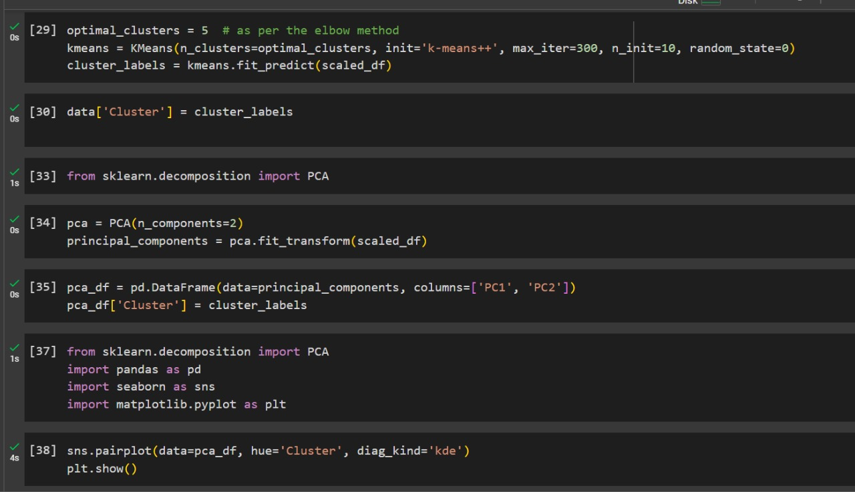

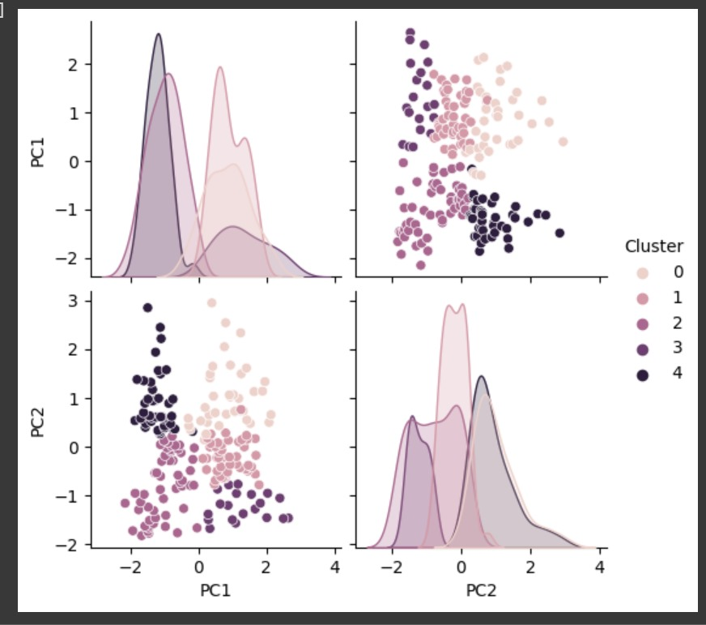

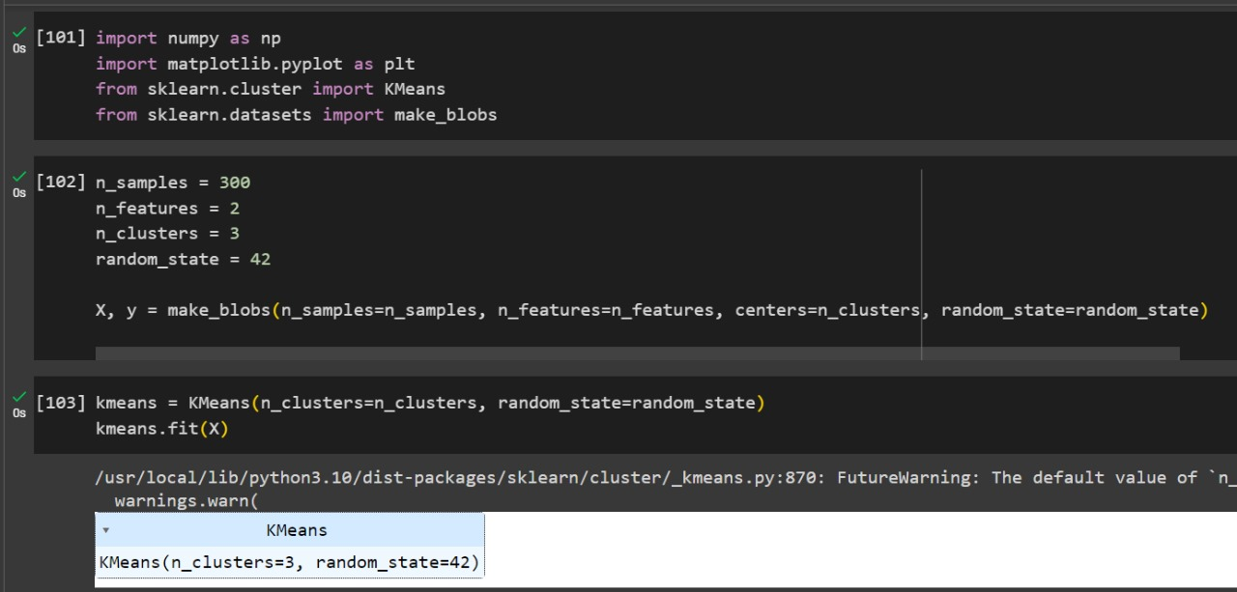

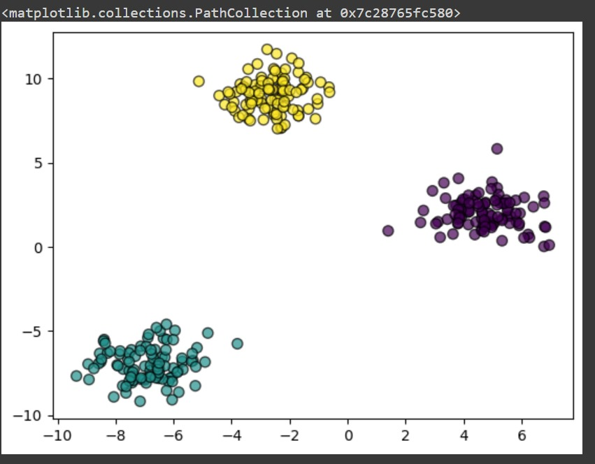

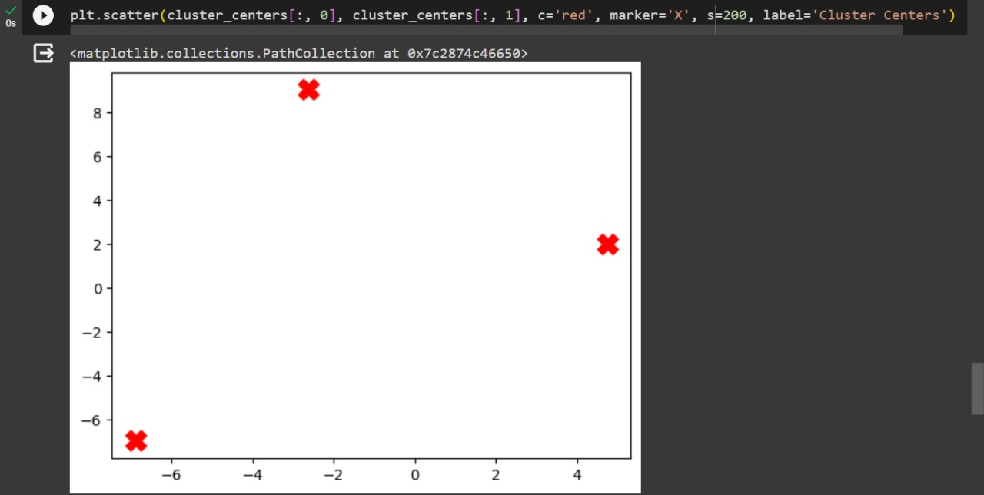

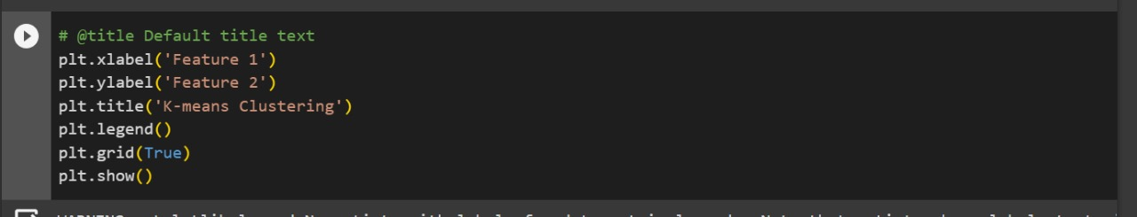

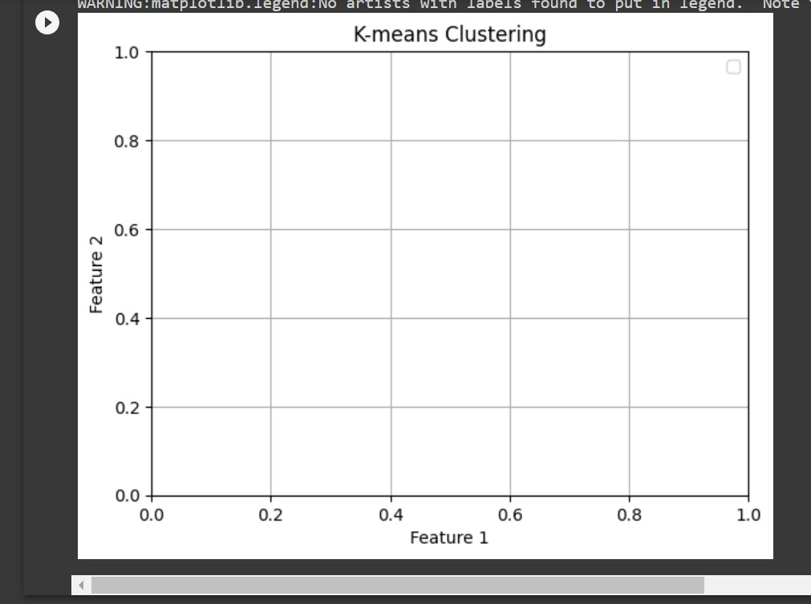

**Thank you**

**SUBMITTED BY:**

**K.PAVITHRA**

**3RD YEAR CSE**